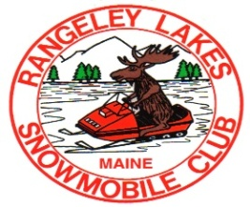
RANGELEY LAKES SNOWMOBILE CLUB MEMBERSHIP RENEWAL FORM
RLSC, PO BOX 950 RANGELEY, ME 04970
rlsc.secretary@gmail.com

Name: ___________________________________________________________

Mailing Address:_______________________________________________________

EMAIL ADDRESS:__________________________________________________

Date of Birth: Phone #:

MEMBERSHIPS:
INDIVIDUAL MEMBERSHIP $30

FAMILY MEMBERSHIP $45

GOLD MEMBERSHIP $65
(Sticker & MSA Sticker)

PLATINUM MEMBERSHIP $105
(Sticker & MSA Sticker)

RLSC CALENDAR RAFFLE: $10 EACH
Membership Level Chosen:_________________ $__________

RLSC Calendar Raffle # of Tickets:____________ $__________
Winner will be drawn everyday for the month of January.
If you name is picked, it will go back in. You could win multiple money prizes.
Please check our website and
Facebook for the raffle calendar.
Groomer Fund Donation:___________________ $__________
(not required, but much appreciated)

Total: $__________

Check# ___________
Checks Payable to: RLSC

Membership Level:

RLSC Groomer Raffle:

Donation To Groomer Fund:

Total Amount Due:

CHECK PAYABLE TO: RLSC CHECK#

**Please check here if you do not want your email shared

